Grade 7 Accelerated · Unit 4 · Lesson 4  Real-World Problems and Significant Digits  Independent Set 4.04 | Name______________________  Date______________________  Period____________________

Six questions, on your own, in silence. Show the step that does the work.
1. How many significant digits are in 6,030 grams?

2. How many significant digits are in 0.00710 meters?

3. A rectangle measures  m by 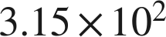 m. Find its area, to the correct number of significant digits.

4. 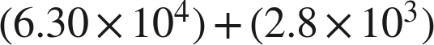 meters, both measured. Write the sum with the correct precision.

5. A car travels  km in 4.0 hours. Find its average speed, to the correct number of significant digits.

6. grams, both measured. Write the difference with the correct precision.

